# **Email in Django**

Start New Project EmailSend Do all Basic Settings

Start Project

1)Set Environment

venv/Scripts/activate

2)Install Django

ensure you have Django installed.

pip install django

3)Create a new Django project using the following command:

django-admin startproject EmailProject .

4)Create a new Django appusing the following command:

python manage.py startapp EmailApp

5)Add app name into settings.py INSTALLED_APP

6)

Configure Email Settings in settings.py

First, open your project's settings.py file and add the following configurations for sending email:

Configure SMTP Settings:

* In the settings.py file of your Django project, configure the SMTP settings for Gmail:

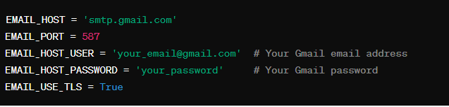

7)**Define EmailSend View:**

* **Create a new view function within one of your Django app's views files (e.g.,** views.py**).**
* **Import necessary functions:**
* **The** EmailSend **function is a Django view responsible for sending emails.**
* **It utilizes Django's** send_mail **function to send an email with the specified subject, message, sender's email address, and recipient email addresses.**
* **Parameters:**
  + **Subject: "Checking Mail in Django"**
  + **Message: "Message shared using Email programmed using Django"**
  + **Sender's Email: sendermail@gmail.com**
  + **Recipients: receiver1@gmail.com, receiver2@gmail.com**
* **The** fail_silently **parameter is set to** False**, meaning it will raise an exception if sending fails.**

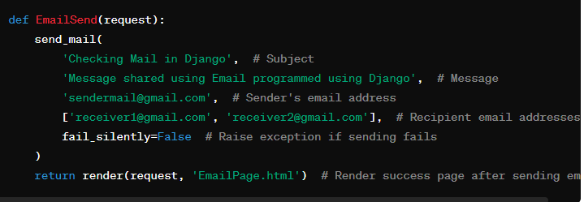

Parameters:

* Subject: "Checking Mail in Django"
* Message: "Message shared using Email programmed using Django"
* Sender's Email: sendermail@gmail.com
* Recipients: receiver1@gmail.com, receiver2@gmail.com
* Fail Silently: False (Raise exception if sending fails)

8. Rendering Success Page:

* After sending the email, the function renders the EmailPage.html **template.**
* **This template confirms the successful email transmission to the user.**

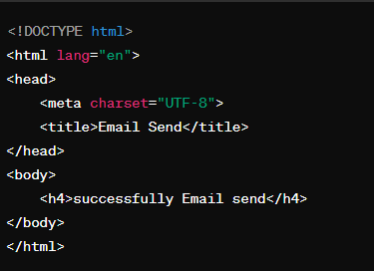

* <!DOCTYPE html>**: Specifies the document type and version of HTML being used.**
* <html lang="en">**: Defines the root element of the HTML document and specifies the language as English.**
* <head>**: Contains meta-information about the HTML document, such as the character set and the title.**
  + <meta charset="UTF-8">**: Specifies the character encoding for the document as UTF-8, which supports a wide range of characters.**
  + <title>Email Send</title>**: Sets the title of the webpage to "Email Send".**
* <body>**: Contains the visible content of the HTML document.**
  + <h4>successfully Email send</h4>**: Displays a level 4 heading with the text "successfully Email send". This is the success message indicating that an email has been sent successfully.**